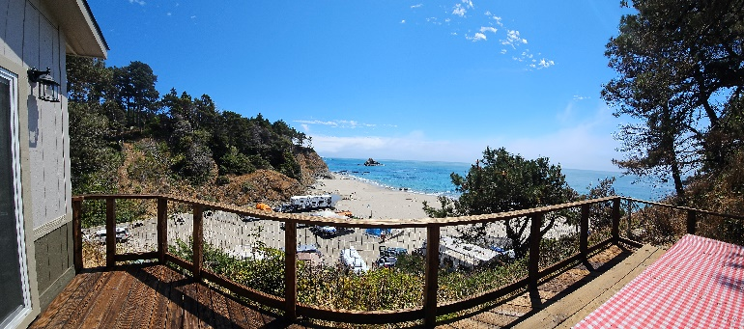

Crow’s Nest at Anchor Bay Campground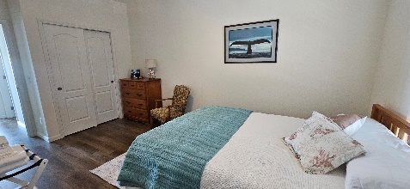 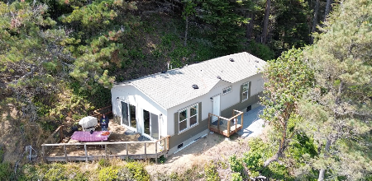 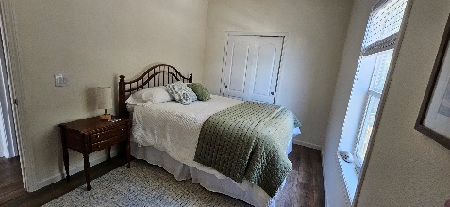 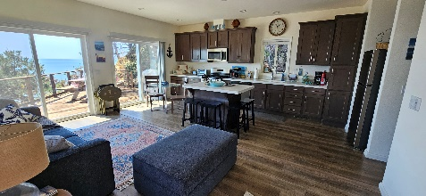 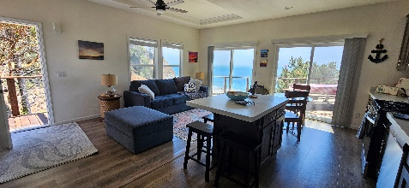

Welcome to the new and improved Crow's Nest!

The rental details are as follows:

$375.00 per night (2 night minimum) + Transient Occupancy Tax of 10%

(TOT of $37.50 per night brings the price to $412.50 per night)

6 person maximum (there are two bedrooms, two bathrooms and a fold out couch in the living room)

$150.00 non-refundable cleaning fee

$10.00 non-refundable reservation fee

Pets are discouraged in this beautiful, new home; however, if you wish to bring your furry friends an additional $100 per pet will be added to the non-refundable cleaning fee.

3% service fee added for credit card purchases.

